

**GHHIN at the International Congress of Biometeorology (ICB) 2017**

**Durham, UK. 4th-7th September 2017**

___________________________________________________________________________

**Summary:**

*There was also a chance to introduce GHHIN in a presentation and open forum to the attendees of the conference, which provided a good opportunity to hear feedback from potential users and contributors.*

*A consensus was that GHHIN was moving in the right direction. From around 30 attendees, suggestions were provided and were noted.*

**Key outcomes and actions from the week:**

1. How to generate dialogue in an open forum environment (deployed from Engagement Strategy)
2. Organizing the 2018 Global Forum
3. Website facility to contribute Heat Health Action Plans
4. Tracking dashboard of extreme heat events and impacts around the world
5. Improve co-ordination More frequent action updates for in-between meetings
6. Video conferences to share screen to assist in sharing documents
7. How to make GHHIN feel ‘real’:
   1. Pilot project somewhere
   2. Exchange and training opportunities
   3. HEAT-shield collaboration for impacts on labour and productivity
   4. Highlighting concrete partners

**Material to share:**

1. PDF of brochure
2. Slides for GHHIN introductory presentation

**Monday 4th September 12pm – 1:30pm BST: GHHIN steering committee meeting**

Agenda:

1. Planning of GHINN presentation Tuesday 5th September 2017
2. General discussion on direction of GHHIN

Participants:

1. Kris Ebi
2. Sarah Giltz
3. Hunter Jones
4. Hannah Nissan
5. Glenn McGregor
6. Virginia Murray
7. Robbie Parks
8. Joy Shumake-Guillemot
9. Juli Trtanj

___________________________________________________________________________

1. Planning of GHHIN presentation 5th September 2017

*Agreement that the GHHIN presentation would take the following structure:*

* 20-minute overview of GHHIN, including:
  + Short history of GHHIN
  + Problem GHHIN addresses
  + What GHHIN is
  + What GHHIN will do
  + Invitation for feedback
* 10-minute open discussion for feedback from audience

1. General discussion on direction of GHHIN

* Idea of creating GHHIN collaborating centres with WHO regional offices.
* Agreed upon need to move on from structure of steering and executive committee to planning global forum next year.
* Important short-term priority was to upload stocktaking of Heat Health Action Plans to GHHIN website
* Student exchanges under GHHIN was something that could be done in the near-term without much required funding
* ‘Synthesis report’ now to be referred to as ‘Science and Action synthesis report’

**Tuesday 5th September 2017 6pm – 6:30pm BST: GHHIN introductory presentation**

Agenda

1. Introduce GHHIN to the wider network of biometeorologists at ICB 2017
2. Obtain feedback and suggestions on GHHIN and how it can best serve its aims

Participants

1. Kris Ebi
2. Sarah Giltz
3. Hunter Jones
4. Hannah Nissan
5. Virginia Murray
6. Robbie Parks
7. Joy Shumake-Guillemot
8. Juli Trtanj

___________________________________________________________________________

1. Introduce GHHIN to the wider network of biometeorologists at ICB 2017

*The introduction to GHHIN lasted 20 minutes, was attended by 30 participants, and some specific questions were raised to members of the audience:*

1. *Have we framed the problem correctly?*
2. *What would you find of value to make it worth your while to participate?*
3. *What do you think the community (producers, consumers, facilitators of info) needs?*
4. *Where do you think you fit and can contribute to such a network?*
5. Obtain feedback and suggestions on GHHIN and how it can best serve its aims

*Overall, the reception to GHHIN was positive. Participants in the discussion generally agreed that GHHIN fulfilled a useful purpose (that is, linking local knowledge and solutions globally  
to address the challenges of extreme heat and human health).*

*Some specific comments follow:*

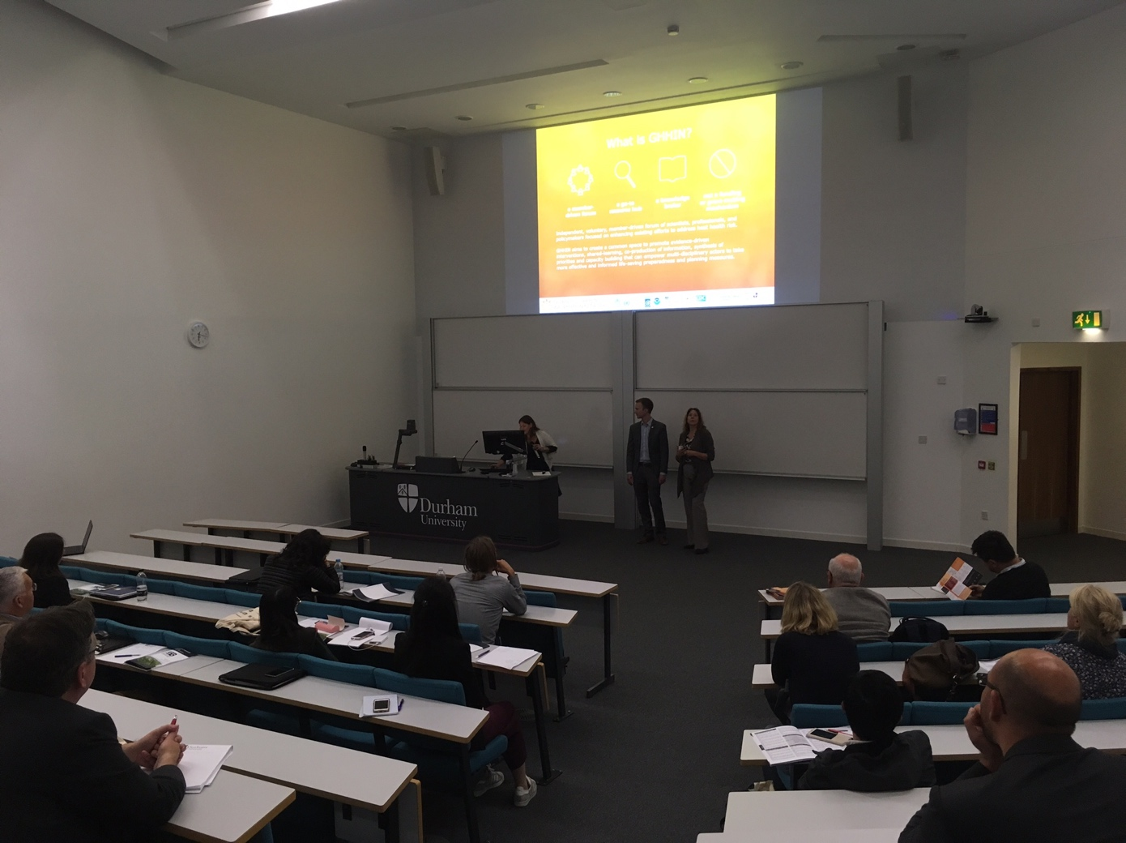

Participants:

* John Nairn:
  + Already great research out there. Operationalization should be the focus of this.
  + Demand community needs an opportunity to add their requests, that are traceable over time.
  + Otherwise it will be difficult to understand if they are fulfilling their targets or not.
* Christina Koppe:
  + How to get smaller countries involved and aware of GHHIN. It is difficult to get to the right people who are working with heat warnings.

* Tord Kjelltstrom:
  + We should try to avoid dominating the health vulnerability focus on just elderly people.
  + Children are important too.
  + Millions of working people are extremely vulnerable but underappreciated. EU founded HEAT-SHIELD to focus on how to protect working people.
* Jane Baldwin:
  + It is important to be able to get people to upload their papers.
  + Tagging and commenting on papers is also important so that people can share their opinions.

**Wednesday 6th September 12pm – 1pm BST: GHHIN core group discussion**

Agenda:

1. Planning for GHHIN Global Forum 2018

Participants:

1. Sarah Giltz
2. Hunter Jones
3. Robbie Parks
4. Joy Shumake-Guillemot
5. Juli Trtanj

___________________________________________________________________________

1. Planning for GHHIN Global Forum 2018

* Finding a venue was still a critical requirement to the planning of the GHHIN Global Forum
* Is the Science and Action synthesis report going to be mainly informed by the discussions at the forum? It may make the report’s evaluation of priorities and good practise more open and democratic